# Mobile Applications Android setup

By Nick Thomas

## Getting android

You don’t need to do this in 609. Its only included incase you need to get android installed and set up on your laptop.

### Downloading Android

* Go to developer.android.com/sdk/installing/index.html
* Chose “Stand-alone SDK Tools”  
  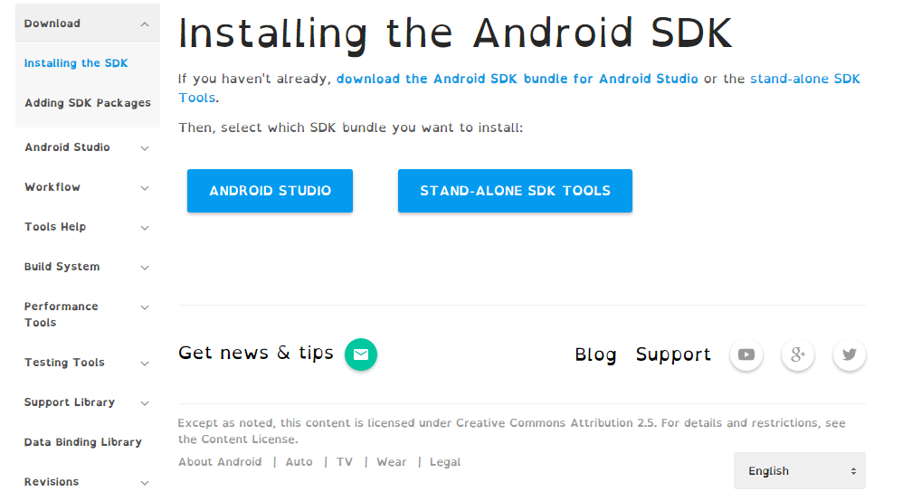
* Chose “download SDK now”  
  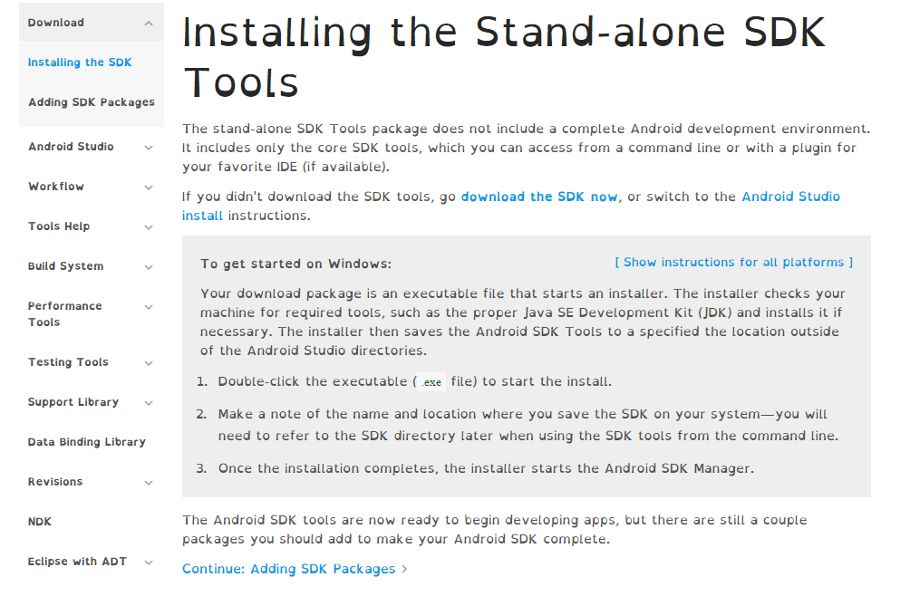
* You want the   
  windows installer.  
  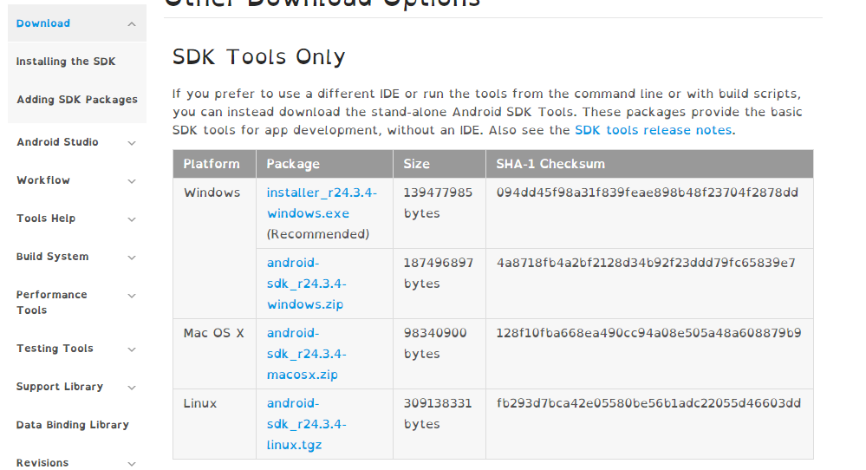
* Run the installer
* After the installer has   
  finished, run the SDK  
  manager

SDK manager

When you run the SDK manager you will see a like tools with check box’s to their left.

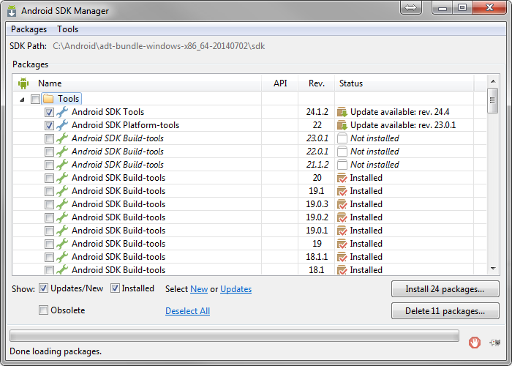

Scroll down till you find Android 4.4.2 (API 19), which is currently the most used version and check the check box next to it

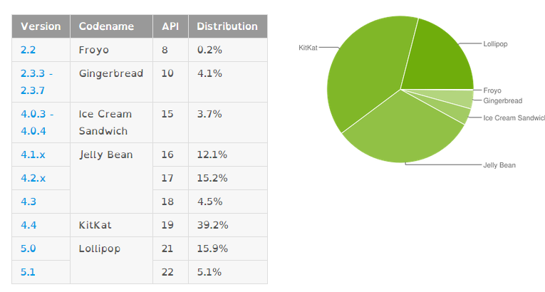

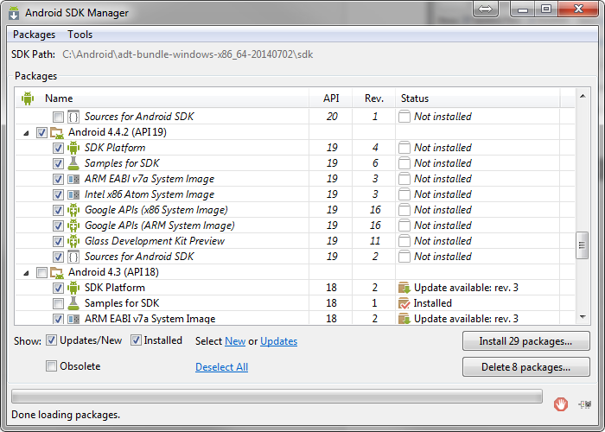

But the version you will need will be dependent on the android system version of your phone, so make sure you get the correct one for you.

Click the install button and get yourself a coffee, it might take a few min to install.

Once this has finished, give yourself a pat on the back, you have successfully installed android!

### Make sure you have Java!

Before you can setup unity with android, you need to make sure that you have the Java Development Kit Installed (JDK).

You can get it from <http://www.oracle.com/technetwork/java/javase/downloads/index.html>

Just run the installer and follow the instructions.

## On to the bit you CAN do in 609

Open Unity!

* Got to edit/preferences/external tools
* Click brows, next to android SDK location
* Then navigate to the install directory for android  
  (in my case, this was c:/Program files(x86)/Android/android-sdk)
* And click “select folder”
* Now select File/Build Settings
* Select android from the platforms list
* And click “player settings…”  
  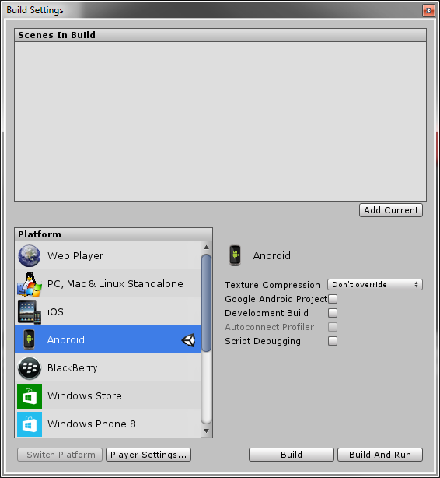
* The player setting will appear in the inspector
* Expand the “other settings” panel
* And change the “PlayerSettings.bundleIdentifier “ from com.Company.ProductName to   
  com.MyCompany.MyTestGame
* 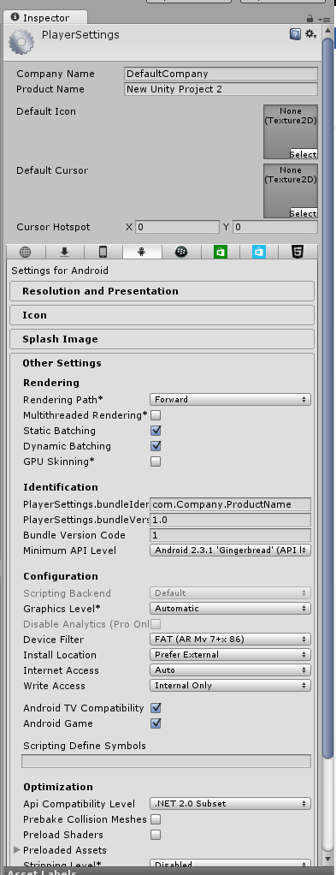

Every android application must have a bundle ID and it MUST be unique. Google tries to inforce this by making developers use the convention com.CompanyName.ProductName.

Now that you have set up unity with android, it’s time to test it all out!

In the build settings, press the build button, NOT BUILD AND RUN!

Build and Run will build you application and attempt to run it on a device (which you don’t have yet).

## The fun bit!

Now that android is set up, we need a simple game to test it with.

So place a cube in your scene and attach a scrip that does the following

public float speed = 0.1F;

// Update is called once per frame

void Update () {

if (Input.touchCount > 0 && Input.GetTouch(0).phase == TouchPhase.Moved)

{

// Get movement of the finger since last frame

Vector2 touchDeltaPosition = Input.GetTouch(0).deltaPosition;

// Move object across XY plane

transform.Translate(-touchDeltaPosition.x * speed, -touchDeltaPosition.y * speed, 0);

}

}

Plug a phone in to your computer and press Build and run in the Build settings (or press Ctrl+B)

You project will build and be automatically pushed to the attached device.

Can you move the cube with you figure?

Good!

## Basic Input

Simply to get you going ASAP, here are some functions that maybe useful for getting input from the phone:

Input.getTouch

Input.touchCount

Input.acceleration

A link to the documentation for you reference:

<http://docs.unity3d.com/ScriptReference/Input.html>

Using these functions and the code snippet above, try and make a simple game.

Can you get multi touch in there as well?

## Setting up the emulator

Once you have finished making your simple game/ games it time to move on to setting up an android emulator.

In the Android SDK manager, go to Tools/Manage AVD’s

In the new window, click “create”  
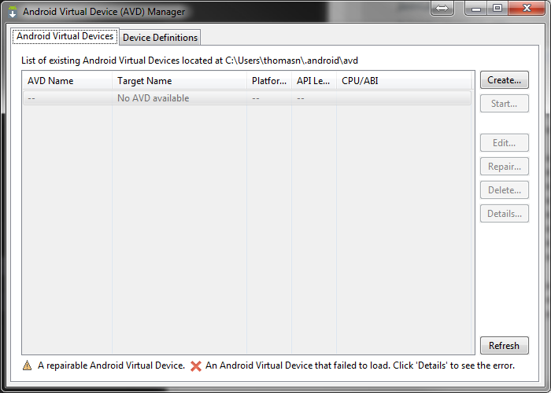

In the following window, use these settings:

AVD Name: *any name you want*

Device: Nexus 5

Target: Android 4.4.2

CPU/ABI: ARM

Keyboard: leave this checked

Skin: no Skin

Front camera: None

Back Camera: none

Memory options: leave these alone

Internal storage: leave this alone

Emulation Options: check “Use Host GPU”

Your setting should look similar to this   
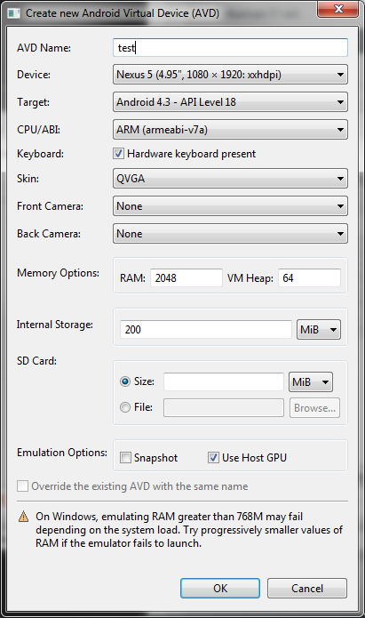

And Click ok

Now Click Start  
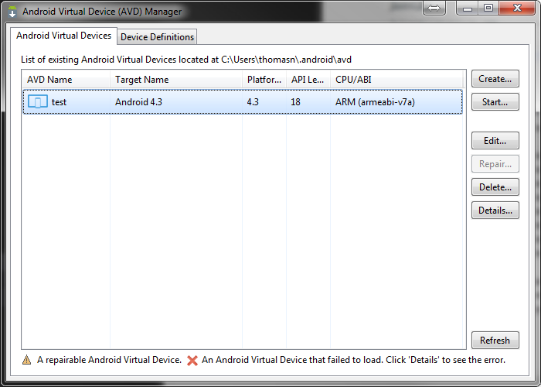

Now wait for the AVD to boot (this may take some time)

Congratulations! You have a virtual Android Device you can now test you apps on, if you don’t have a phone. I recommend you use a phone for development if you can. The emulator is extremely slow.